Go to SE11.

Select the ZXXXXXXEMP table created by you. Click on Append Structure.



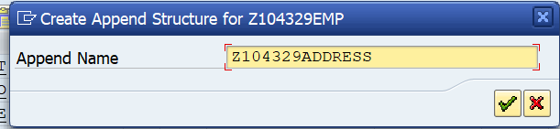

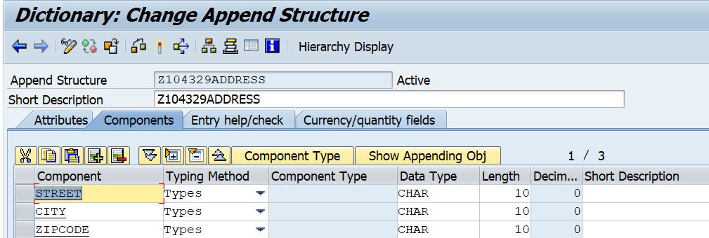

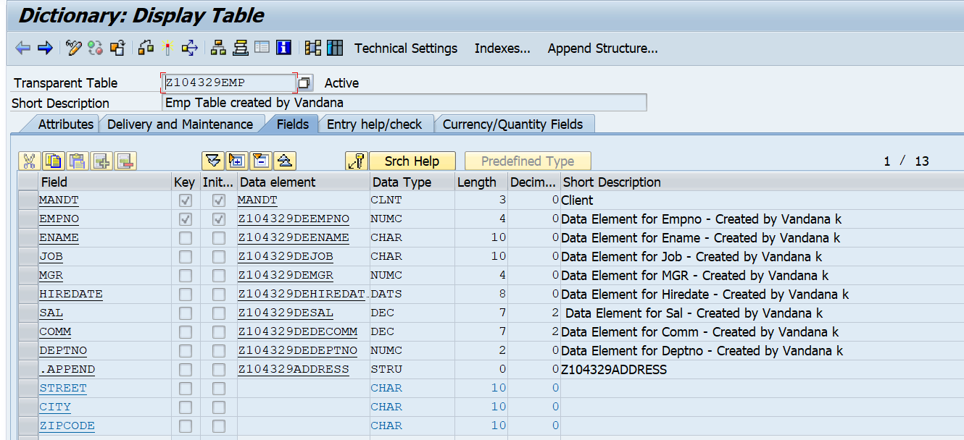

Utilities-Table Contents-Create entries.

